# Mission Ready Level 5 – Mission 1

## Resources used

Build a basic chatbot using Microsoft Azure (For building Echo bots which is not what we need for this project)

<https://www.youtube.com/watch?v=rFw-mCfStEM>

Detailed documentation (Not that great of a documentation)

<https://stackify.com/create-azure-bot-service/>

Qnamaker -> Fairly straightforward

<https://www.qnamaker.ai/>

How to get started with Azure QnA Maker and publish a bot quickly | Azure Developer Streams

* Can follow her YouTube guide if you prefer to visually learn, its pretty much the same as above.

<https://www.youtube.com/watch?v=sxy9ZTC3BhA>

You will also need a Microsoft Azure account 🡪 Requires a credit card at sign up as well.

<https://www.qnamaker.ai/Home/MyServices>

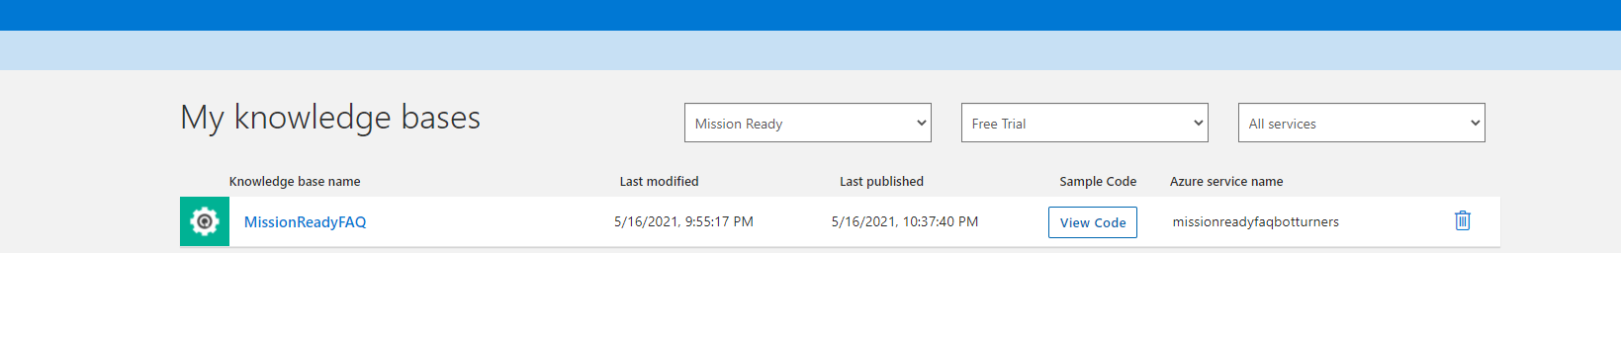Only Johnny currently has access to it.

Have to create FAQ / QNA via [www.qnamaker.ai](http://www.qnamaker.ai) then make the bot via the azure portal which will link you to it.